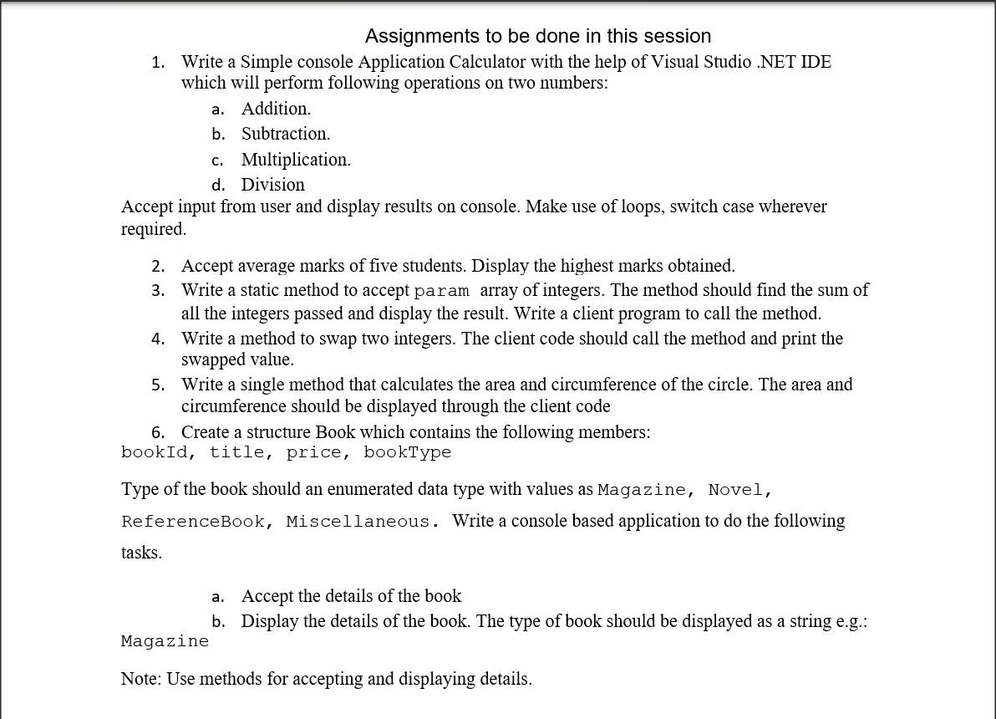

1.

using System;

class program

{

public static void Main()

{

Console.WriteLine("Enter any two numbers:-\n");

Console.WriteLine("Enter first numbers:-\n");

int firstNumber = int.Parse(Console.ReadLine());

Console.WriteLine("Enter second numbers:-\n");

int secondNumber = int.Parse(Console.ReadLine());

//calculator

//1. Addition

float f = 0;

f = firstNumber + secondNumber;

Console.WriteLine("Addition of two numbers is {0}", f);

//2. substraction

f = firstNumber - secondNumber;

Console.WriteLine("Substraction of two numbers is {0}", f);

//3. Multiply

f = firstNumber \* secondNumber;

Console.WriteLine("Multiplication of two numbers is {0}", f);

//4.Division

f = (float)firstNumber / (float)secondNumber;

Console.WriteLine("Divison of two numbers is {0}", f);

Console.WriteLine("\n");

Console.WriteLine("\n");

//tables of any number

Console.WriteLine("Enter any number which you want multiplication");

int enterNumber=int.Parse(Console.ReadLine());

for (int i=1; i<=10 ;i++)

{

int table = enterNumber\*i;

Console.WriteLine("{0} X {1} ={2}",enterNumber,i,table);

}

//switch-case statement

Console.WriteLine("Enter any number to check for even or odd");

int num=int.Parse(Console.ReadLine());

switch(num%2)

{

case 1:

Console.WriteLine("{0} is odd",num);

break;

case 0:

Console.WriteLine("{0} is even",num);

break;

default:

Console.WriteLine("invalid value");

break;

}

}

}

Output

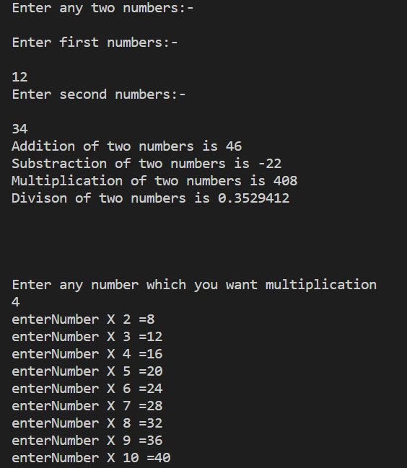

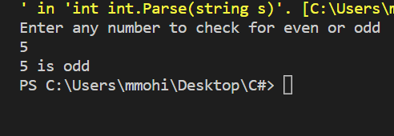

2.

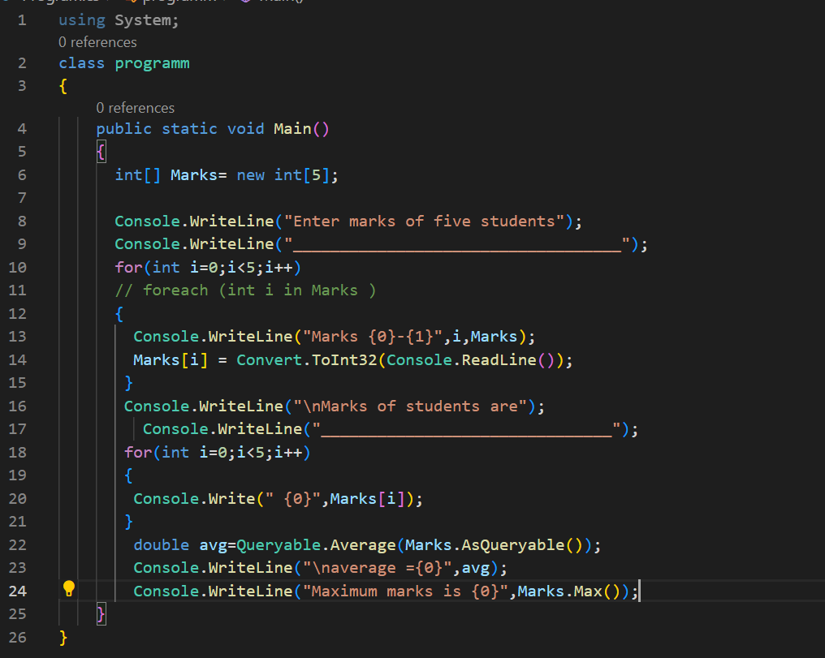

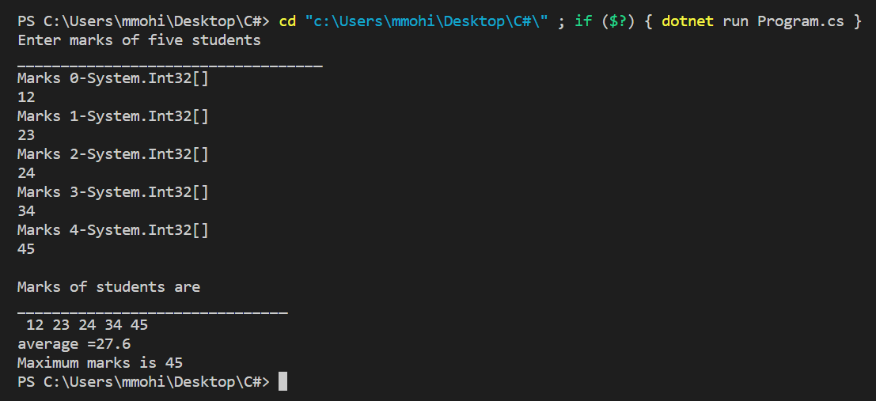

3.

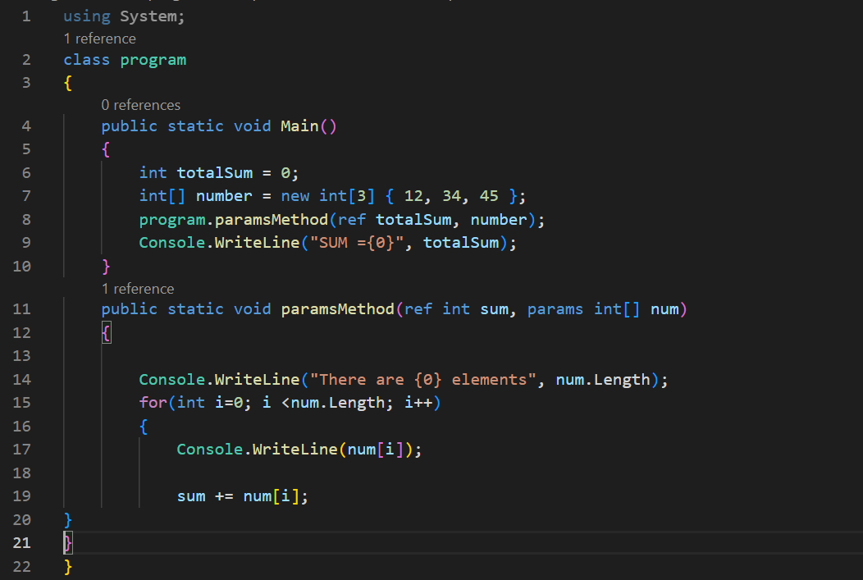

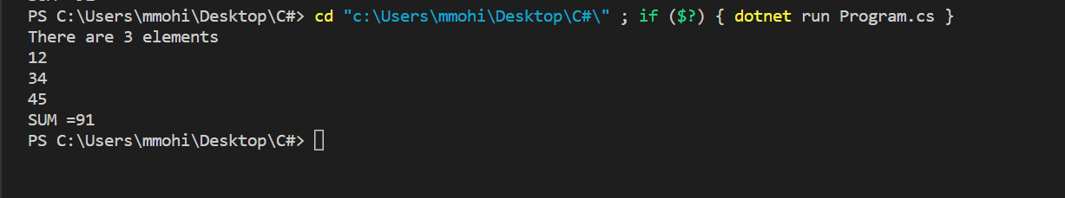

4.

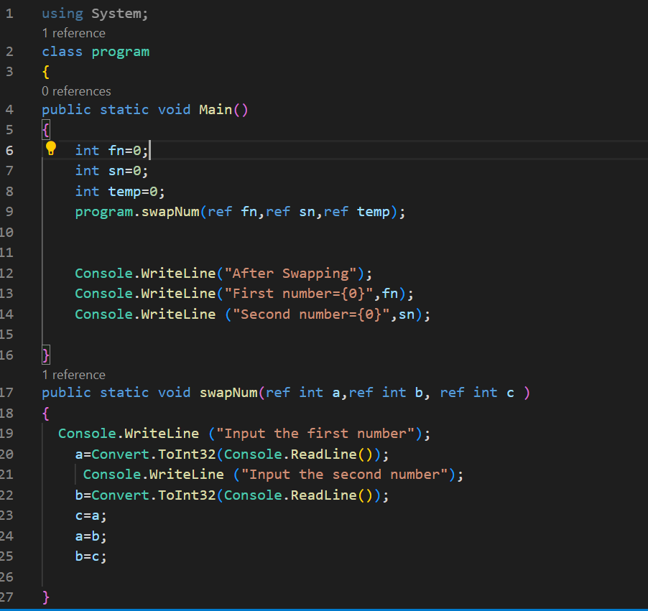

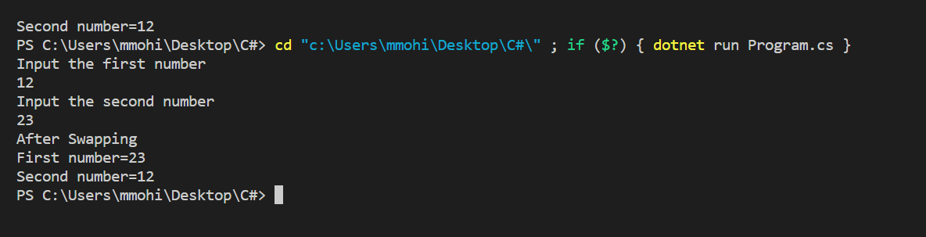

5.

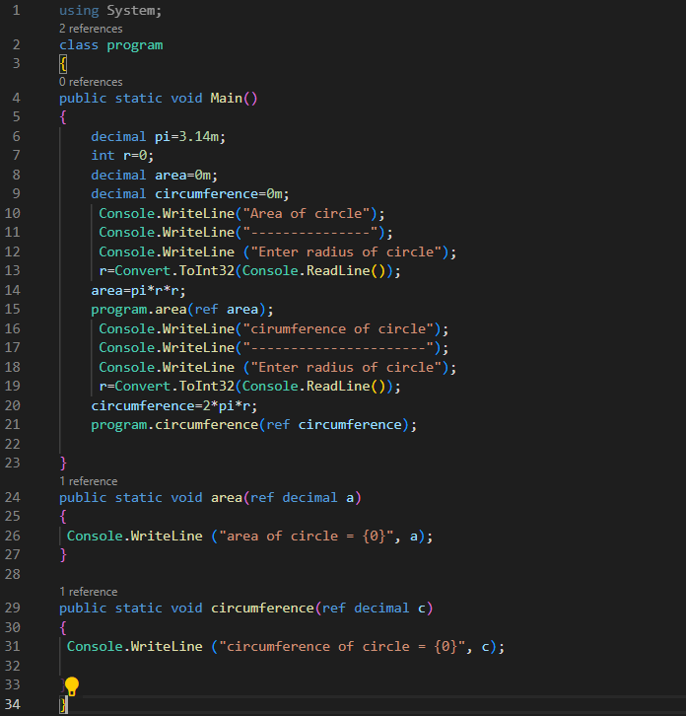

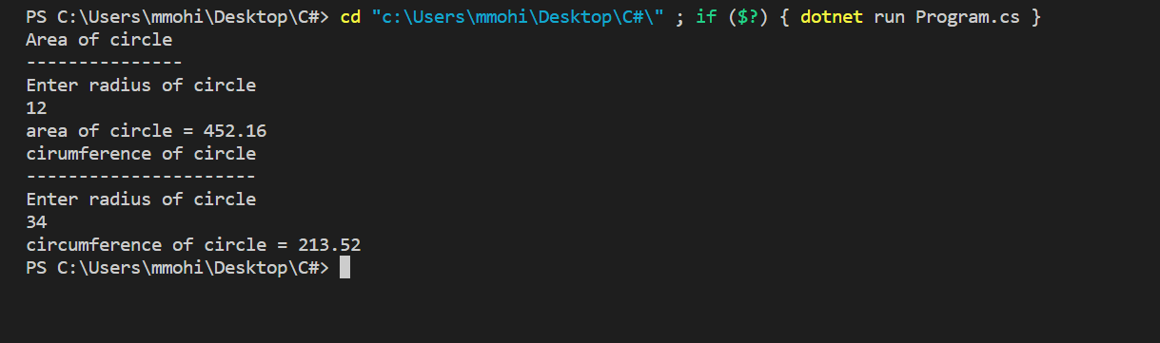

6.

using System;

public struct Books

{

private int BOOKID;

private string TITLE;

private int PRICE;

private string BOOKTYPE;

public int bookid

{

get {return this.BOOKID;}

set{this.BOOKID=value;}

}

public string Title

{

get {return this.TITLE;}

set{this.TITLE=value;}

}

public int Price

{

get {return this.PRICE;}

set{this.PRICE=value;}

}

public string booktype

{

get {return this.BOOKTYPE;}

set{this.BOOKTYPE=value;}

}

public Books(int bookid,string title,int price,string booktype)

{

this.BOOKID=bookid;

this.TITLE=title;

this.PRICE=price;

this.BOOKTYPE=booktype;

}

public void PrintDetails()

{

Console.WriteLine ("BookId ={0} , Title ={1} ,Price={2} ,BookType={3}",this.BOOKID,this.TITLE,this.PRICE,this.BOOKTYPE);

}

}

public enum bookType

{

magazine,

novel,

referenceBook,

miscllenous

}

public class program

{

public static void Main()

{

Books b1= new Books(101,"Bio",20,bookType.magazine);

b1.PrintDetails();

Books b2= new Books(102,"Phy",30,bookType.novel);

b2.PrintDetails();

Books b3= new Books (103,"civics",20,bookType.miscllenous);

}

}

